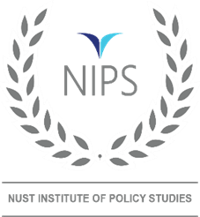
US-China Escalating Competition in Indo-Pacific: Challenges and Choices for Pakistan
Sayyeda Aqsa Sajjad
Research Associate-NUST Institute of Policy Studies
Email: researchassociate1.nips@nust.edu.pk

Indo-Pacific comprises Indian and Pacific Oceans that are connected through the Malacca Strait/South China Sea. The region thrives with global trade. Its littoral states are endowed with energy resources. About 80 percent of world trade is carried out over the water ways, of which 60 percent is conducted through the sea lanes of communications housed by the Indo-Pacific. Besides, this region constitutes 65 percent of the world population. The Indo-Pacific Economic Framework, recently formed by the USA and twelve regional states constitute 40 percent of world GDP. The human capital, trade and energy make it an attractive destination for world powers. The rise of China as a competitor however, becomes a challenge to the US supremacy here. The South China sea states have their internal territorial disputes too that exacerbate China-USA competition. All told the region has evolved as a center stage of world politics.
Chinese rise over the past few decades, through soft power, appears to be reshaping the global political landscape. China is being viewed as a challenger to the existing world order dominated by the USA as sole super power. The states are increasingly involved in engaging regional states in economic and security pacts leaving less chances for smaller states of the region like Pakistan to stay non-aligned. This paper aims to analyse American and Chinese escalating competition in the Indo-Pacific Region and study their impact on Pakistan.
The US conduct of international relations is increasingly becoming dominated by China containment efforts. The USA has, therefore, increased its involvement in Asia, especially the Indo-Pacific Region over past few decades and came up with various forums and multiple alliances, commencing with “Pivot to Asia” policy in 90s. Quadrilateral Security Dialogue commonly known as QUAD launched in 2007 initiated a closer, but informal security cooperation in the Region comprising USA, India, Japan and Australia. It aimed at forestalling Chinese domination in the region, with announced purpose of keeping the Indo-Pacific Ocean’s Sea lanes free from any political or military influence.
Furthermore, a modified focus after President Donald Trump’s visit to Asia in 2017 resulted in passing of the Asia Reassurance Initiative Act (ARIA) on 31 December 2018. The ARIA allocated US$1.5 billion for undertaking a range of US programmes in East Asia and Southeast Asia to “develop a long-term strategic vision and a comprehensive, multifaceted and principled US policy for the Indo-Pacific region”. Since then, USA is rejuvenating the existing ties and forging new alliances with Indo-pacific states i.e., Abrahamic Accords in 2020, AUKUS in 2021, I2U2 in 2021 and IPEF in 2022 were added to further strengthen these alliances, which aim at territorial containment of China; when needed to interdict Chinese Sea Lines of Communications (SLOCs) in Malacca Strait. In these steps, strategies, alliances and forums India has been termed as US strategic partner, hence a US bulwark against Chinese rise.
Abraham Accord was concluded with US help between Israel and UAE, Bahrain and Morocco to normalise their relations apparently also gave a break to the expanding Chinese-Israel trade ties and capital flow. It was followed by AUKUS which is an ardent security alliance comprises Australia, UK and USA. This also focuses on containment of China. Under this pact the USA will be providing nuclear submarines with fuel and back up technology to Australia. On the other hand, I2U2 that is a grouping comprising Israel, India, UAE and USA to collaborate in economic, technological and private sectors including enhanced cooperation in trade, infrastructure development and renewable energy. It was termed as a new Quad by some writers too.
Moreover, Indo-Pacific Strategy of the United States published in February 2022 is based upon three pillars i.e., consolidating partnerships, deepening coalitions and strengthening alliances; enhancing trade relations with the states and creating new opportunities to engage partners; and increasing deterrence and encouraging long term peace and stability in the region.
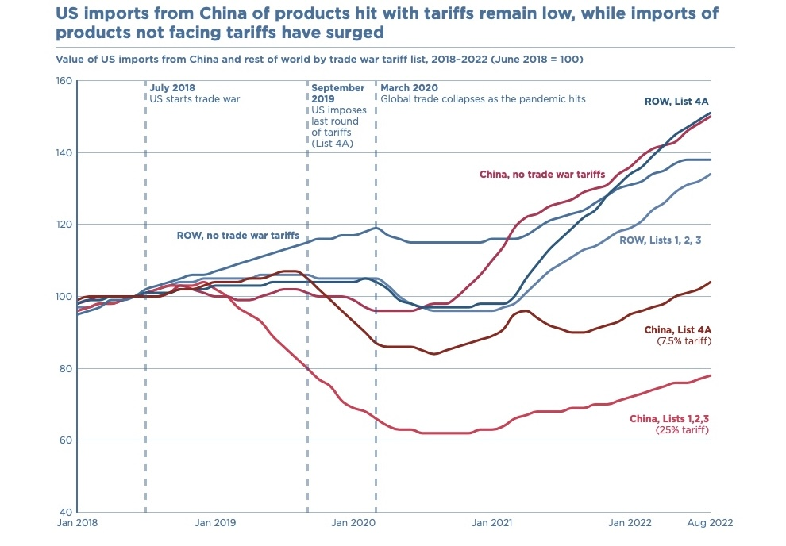
Indo-Pacific Economic Framework (IPEF) is another initiative by the Biden administration to offset the negative consequences of US walking out of Trance Pacific Partnership. It includes Australia, Brunei Darussalam, Fiji, India, Indonesia, Japan, Republic of Korea, Malaysia, New Zealand, Philippines, Singapore, Thailand, and Vietnam. It aims at connectivity, trade and maintenance of supply chains, clean energy, de-carbonisation and infrastructure development, tariff concessions and anti-corruption. USA has kept 150 million USD to kick start this forum. Amid the competition with China, the USA is trying to induce peripheral states as well to join in her this effort. US has even started coercing non-aligned states to wean away from China, forcing binary choices upon them. Presently Pakistan appears to be facing similar pressures due to its long-term strategic relationship with China. Consequent to this, demonization of China Pakistan Economic Corridor (CPEC) by USA, her allies and India is also vivid. Likewise, US is also trying to contain China in multiple tech and non-tech domains including acquisition of high-end technology through digital authoritarianism, denying access to artificial intelligence, surveillance technologies, and satellite-based navigation not only for military uses but in 6G telecommunications for civilian use. Both states had imposed heavy tariffs on each other’s products as tit for tat measures of trade war. This discernibly affected the trade between them, and countries like Vietnam benefitted as a consequence.
Source: Peterson Institute for International Economics
In response to US containment efforts China has also made attempts to enhance her influence in the Region by developing politico-economic alliances with the Indo-pacific states. Belt and Road Initiative (BRI) that commenced in 2013 has helped China in expanding her sphere of economic influence, which is termed and propagated by USA, her allies and India as a strategic initiative to dominate world economy and supply chains with China at its centre. Furthermore, Regional Comprehensive Economic Partnership (RCEP) in 2020 and China-Solomon Island Pact in 2022 to counter US initiatives also contributed in expanding Chinese influence around the globe in general, and in the region in particular.
Cognizant of US efforts to isolate and contain it, China started taking counter measures to reduce increasing US influence, especially in the Western Pacific. China has been engaged with the South Pacific countries for over three decades through various regional forums such as the Pacific Islands Forum (PIF) and China Pacific Island Countries Forum (EDCF) started in 1990. China provides about $1 million each year to the EDCF secretariat. In 2020, China added a $1.9 million fund to support this region’s response against COVID -19.
Moreover, Regional Comprehensive Economic Partnership (RCEP) made by China is a regional alliance with the purpose to enhance free trade in goods and services, investments, economic and technical cooperation in the region. It is woven around Australia, New Zealand, Brunei Darussalam, Cambodia, China, Japan, Laos, Singapore, Thailand and Vietnam.
China-Solomon Islands Pact is a bilateral security agreement that was inked between China and the Solomon Islands in April 2022. It essentially focuses on boosting the Solomon Islands’ national security capacity. This Pact also encompasses cooperation in humanitarian assistance, disaster response and measure for maintaining a social order. Under this pact Chinese ships can “make ship visits to, carry out logistical replacement in, and have stopover and transition in Solomon Islands,”. More important clause is that Chinese forces can be deployed to “protect the safety of Chinese personnel and major projects.”
The political and economic alliances of both the blocs have catapulted the Indo-Pacific region into a newer complexed and challenging security milieu. These arrangements can be examined through the lenses of the various international relations theories too i.e., Regional Security Complex Theory, Super Security Complex Theory and Complex Interdependence Theory. Considering it in the backdrop of Complex Interdependence, the economic interdependence amongst the states makes it less likely for the countries with intertwined economic interest to engage in a conflict with one another. However, at the same times it knits them into an economic bloc with attendant political sway that may be viewed as a threat by the competing state(s).
There is a possibility that a new Cold War between China and USA may take place. Few opine that it has already commenced in the shape of trade, diplomacy, political economy and technology wars. If it translates into bloc formation it may lead to proxy wars amongst the major powers using smaller partner countries as battle grounds. In such a scenario the smaller states will come under tremendous pressure, and will have to face negative fall outs. USA- China competition induces pressure on the smaller states and forces them to choose sides.
The strategic competition in Asia-Pacific is likely to have adverse impact on South Asia. Nuclearized Indo-Pacific as a result of AUKUS will accelerate arms race in the region. India, being South Asian state and a substantial share-holder of the Indian Ocean coast has joined hands with the USA to contain China in the region. Besides, her extended role in ASEAN, and relationship with Asian and African states, India’s strategic alliance with the USA has amplified her arrogance in bilateral as well as regional relations, especially with Pakistan.
Pakistan, despite having 1046 km coastline with the Indian Ocean, receives much lesser significance in US Indo-Pacific Strategy and US sponsored regional alliances. However, it experiences much more pressure due to evolving geo-strategic environment wherein Indian relevance to USA security interests dominates. Pakistan being friend of China and partner in BRI through its flagship project CPEC has become the victim of proxy wars.
Despite irrefutable proves of Chinese killing by Indian proxies on Pakistan soil, the USA and West look the other way. Pronounced American tilt towards India is adding to the security dilemma for Pakistan. Indian military acquisition of billions of dollars from USA, Europe and Israel are fast upsetting the balance of power in the region, thereby provoking an arms race. Pakistan’s reduced conventional military capability as compared to India could result into a much-lowered nuclear threshold, putting South Asia at the risk of nuclear exchanges in case of a Pakistan-India war. Indian relevance to US strategic designs in the region, and her consequent intransigence also affect the conflict resolution in South Asia, especially with reference to Pakistan’s stance on Kashmir. USA appears to be comfortable with institution of India as regional bully and its bulwark against China. Pakistan needs to play her cards tactfully. It should develop working bilateral and trade relations with India. Pakistan could emulate China in this regard. Despite their strategic and economic competition, keeping the conflicts aside, China and India as well as US and China, are maintaining their trade relations. Their complex interdependence can help minimise the possibility of armed conflict between them. Our National security Policy 2022, prioritises geo-economic and human security. In line with that, Pakistan can also conduct trade with India in a balanced manner. A strong economy, happier and healthier human capital will complement our ability to fight the challenges of the external and internal fronts effectively.
Pakistan occupies a place of geo-economic and strategic significance in the region as the Indian Ocean with proximity to the Strait of Hormuz. Its vicinity to Central Asian States, China and Russia, ability to act as a land bridge for Afghanistan and East Europe make it an important connectivity hub for enhanced trade and connectivity, as well as provide these states transit facilities for their sea borne trade. The stability in Afghanistan is considered crucial to realisation of Pakistan reoriented national security policy. Therefore, all possible efforts be made to bring peace and stability in Afghanistan. For that Pakistan can play a significant role as it has already acted as a facilitator in the US- Taliban peace talks. Afghanistan can be engaged politically, diplomatically as well as economically to project the softer image of Pakistan. Engagements with people and cultural exchange programs are important. Facilitating students by providing them scholarships for higher education in Pakistan may be enhanced. This will help Pakistan to construct its positive narrative in Afghanistan for long-term sustainable relations.
Pakistan enjoys friendly relations with China since decades and BRI flagship project the CPEC carries great potential for Pakistan’s socio-economic development that will complement Pakistan’s traditional as well as non-traditional security. Since CPEC provides Gwadar as an alternative to a disturbed Malacca Strait, hence it is being criticised. It should not compromise on the CPEC. Pakistan also needs to strengthen her ties with regional and extra regional states including SCO and ASEAN countries as well as join other economic forums.
Avoiding bloc politics Pakistan should not ally with any major power in new cold war. As India, for years has maintained the policy of non-alignment. Pakistan can strengthen economic relations with Russia. Russia can be a better substitute for an energy deficient state like Pakistan by providing comparatively cheaper energy supply.
Lastly, Pakistan has been partnering with the USA in the wars and has suffered a lot particularly in the aftermath of US’ war against terror. Being a global hegemon, US has her due significance and Pakistan is not in a position to ignore her. While not compromising own interests, Pakistan should maintain good relations with both; the USA and China. Pakistan should balance out relations with USA, China, Russia, EU, Middle east, Far Asia and Africa. We should not fall a prey to become proxy of any of the major powers.

