SHIFTING GEOPOLITICS IN THE ARCTIC
Atia Ali Kazmi*

‘Whoever has control over the Arctic route will control the new passage of world economics and international strategies.’
Li Zhenfu (Dalian Maritime University, China).

Foreword
Climate change, global warming, and new trends of power politics have brought the Arctic into a unique geopolitical limelight. The melting ice-cap is altering conditions for development of the Arctic while telescoping distances. This great shift offers opportunities and challenges. The big sea-faring powers and others can either integrate their interests or broaden the scope of existing competition. The abundant energy and mineral resources, and reduced maritime routes between Europe and Asia are driving the interest in the Arctic region. If competition becomes the leading trend, there are likely to be creating demands for sovereignty, governance, and the right of passage through the Arctic.
By 2030, the trans-polar passage may become easier during summers due to receding ice-cap. The commercial maritime trade and energy routes, wealth of natural resources that inter alia include an estimated 30 percent of world’s undiscovered natural gas plus around 13 percent of oil reserves, and prospects of hi-tech scientific research are some of the key aspects that are gradually setting up the Arctic region to become the modern-age destination for development as well as an arena for neo-balance in inter-state relations. About 80 percent of this natural wealth and territory is claimed by Russia. The melting shores of Arctic are giving way to warm and tenuous lines, no longer keeping it the so-called Zone of Peace that the former Russian President Gorbachev envisioned in 1987. During the Arctic Council’s meeting in 2019, the United States surprised Canada – one of its closest allies – by including Canada alongside Russia and China as a security threat. The inclusion of Arctic region in Chinese Belt and Road Initiative’s (BRI) Polar Silk Road plan could be one of the reasons that are stirring such reactions.
Stability in the transforming global environment hinges heavily on intentions and behavior of the United States and China – the Arctic is not an exception. The emerging dynamics of U.S.-China relations in the Arctic and the evolving regional balance of power can either offer new trends of intercontinental linkages and infrastructure development, ensuring a win-win for all actors, or become a ruse de guerre that may lead to military confrontation. At the same time, opportunities have emerged for unlocking new passages of global economics and options for an increased activity in the region. The Polar navigation along the Russian coast, the Northern Sea Route (NSR), potentially allows a significant time saving of two weeks as compared to the conventional forty days sea route between China and Europe. Experts and policymakers thus keep analyzing transformation of the Arctic through the prisms of economic, territorial, and geopolitical developments.
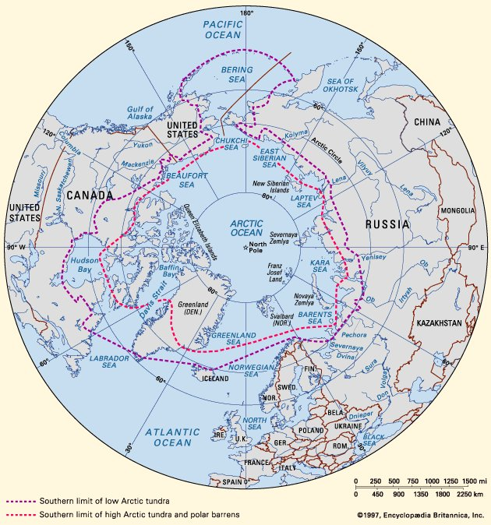
The Arctic Region (Encyclopedia Britannica)

Politics of the Arctic
The international political and legal framework for the Arctic stands on a number of pillars: The Svalbard Treaty of 1992 (originally the Spitsbergen Treaty), the United Nations Convention on the Law of the Sea (UNCLOS) of 1994, and the Arctic Council of 1996.
The Svalbard Treaty establishes Norway’s sovereignty over the Svalbard archipelago and allows citizens of 46 party states – including China, Russia, and the United States – same rights of residence and access in Svalbard.
The UNCLOS aims to ‘regulate all aspects of the resources of the sea and uses of the ocean,’ and considers Canada, Denmark, Norway, Russia, and the United States as littoral states in the Arctic Ocean. Finalized in 1982, the convention became effective in 1994, and 167 countries and the European Union have so far joined it. The United States has signed but not ratified the convention. American domestic debate thus revolves around two contrary valuations i.e. ratifying the convention to enhance commercial utilization of resources and strengthen and protect U.S. interests, or keeping status quo due to concerns about sovereignty and maritime rights, prospective environmental pollution costs, and burden of royalties on American companies for energy exploitation. The 34 members of U.S. Senate opposed ratification in 2012 and then-Defense Secretary, Donald Rumsfeld, smacked the idea noting violation of rules by some members, such as China, in the South China Sea.
The Arctic Council (AC) was established by the Declaration on the Establishment of the Arctic Council (Ottawa Declaration) of 1996 and inaugurated on September 17, 1998. The Council consists of 8 full member circumpolar states – Canada, the Kingdom of Denmark, Finland, Iceland, Norway, the Russian Federation, Sweden, and the United States – that have voting rights. The Council is the ‘leading intergovernmental forum promoting cooperation, coordination, and interaction among Arctic States, Arctic indigenous communities and other Arctic inhabitants on common Arctic matters, in particular on issues of sustainable development and environmental protection in the Arctic.’ Non-Arctic states and global, regional, intergovernmental, inter-parliamentary, and non-governmental organizations, that the AC determines can contribute to its work, are given the observer status. Key agreements include cooperation on enhancing international Arctic scientific cooperation (2017); marine oil pollution preparedness and response in the Arctic (2013); and aeronautical and maritime search and rescue in the Arctic (2011). The Council’s mandate excludes military security and focuses primarily on marine cooperation; connectivity; development of blue bioeconomy; protection and conservation of marine environment and biodiversity; emergency prevention, preparedness, and response; and sustainable development of Arctic ecosystems and human communities as a whole.
China is among the 13 accredited observers of the Arctic Council, including France, Germany, Italy, Japan, the Netherlands, Poland, India, South Korea, Singapore, Spain, Switzerland, and the UK.
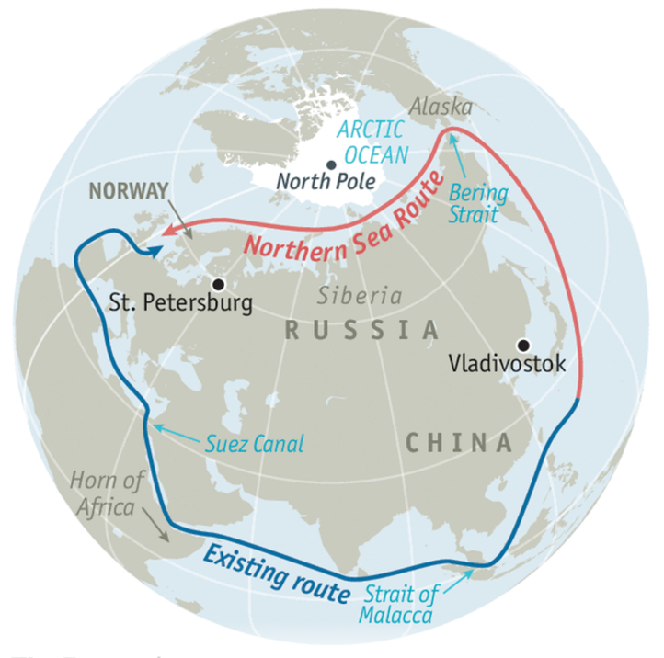
The Northern Sea Route (The Economist)
United States
Maritime routes and vast energy reserves are two of the key attractions for the U.S. in the Arctic region and numerous domestic debates focus on the development of U.S. energy resources there. The largest single field of oil reserves in the U.S. were discovered in 1968 in Prudhoe Bay. The Trans Alaska Pipeline System (TAPS), completed in 1977 at a cost of nearly USD 32 billion in today’s dollars, transports 15 percent of crude oil used in local production from the North Slope in Alaska across the eight hundred miles of tundra to the North America's northernmost ice-free port in Valdez. However, since the U.S. has not ratified the UNCLOS, the exclusive legal titles of the country remain undefined. Hence, it has access to its exclusive economic zone (EEZ) to 200 nautical miles off the coastline only for economic activities such as drilling and fishing. The UNCLOS sanctions extension of a country’s EEZ for resources to a further 150 nautical miles on proving extension of continental shelf that far. Other Arctic states have registered their claims for extended seabed EEZs that reach the North Pole. Experts criticize delays in ratification of the UNCLOS by the U.S. For instance, Andrew Holland posits that ratification ‘is a tool to expand and confirm American sovereignty without resorting to military force. The Arctic Ocean is the region in which American sovereignty is most in doubt.’
Belt & Road Initiative
China seeks stepping into the policy domain of the Arctic through its new century mega-economic plan – the Belt and Road Initiative – that initially covered the Afro-Eurasian Silk Route. China is neither an Arctic littoral state nor enjoys the full membership of the Arctic Council that could allow it the right to participate in regional policymaking discussions. The Chinese government’s Polar Silk Road policy paper though specifies that ‘under BRI, the Polar Silk Road (NSR) would be an alternative to the conventional sea route from Europe to China, crossing the strategically vulnerable Suez Canal and the Strait of Malacca.’
Located almost 2,500 miles south of the Pole, China considers itself a ‘near-Arctic’ state. Since the Arctic’s purported natural resources are in uncontested areas, China has the legitimate right to get a foothold. Once the NSR becomes navigable in summers, ships sailing from the northeastern China to low-countries in Europe could gain a 10-day leap in travel time instead of exposed security choke points like Malacca and Suez. In a decade’s time China anticipates its land-locked regions being unencumbered from the geographical bind and becoming highly developed.
In 2013, at the Polar Conference at Chinese Academy of Sciences, President Xi Jinping said that: ‘Polar affairs have a unique role in [China’s] marine development strategy and the process of becoming a polar power is an important component of China’s process to become maritime great power.’
China has been exploring the polar region onboard the Research Vessel Xuelong (Snow Dragon) since 1994. It joined the International Arctic Science Committee (IASC) in 1997, that aimed to ‘facilitate multidisciplinary research on the Arctic region and its role in the earth system.’ The first Chinese Arctic research station, Huanghe (Yellow River), was established in July 2004 at Ny-Alesund in Norway's Svalbard archipelago. Half of China’s GDP is said to be dependent on shipping and Shanghai-Hamburg transportation through NSR – running along Russian north coast from Bering Strait in the east to Novaya Zemlya in the west – that is around 6,400 kilometers shorter than the route via Suez Canal and Strait of Malacca. China had carried out eight scientific expeditions in Arctic Ocean by the end of 2017 along with 14 years of research at the Huanghe Station base. China’s tech-based involvement also includes use of icebreakers and weather satellites (Linda Jacobson: SIPRI).
The white paper published by the State Council Information Office of China on January 26, 2018, presents salient goals, principles, and major policy positions of ‘China’s Arctic Policy’ while expressing cognizance of the region’s ‘rising strategic, economic values and those relating to scientific research, environmental protection, sea passages, and natural resources.’ Given the fact that predicted changes in natural environment of the Arctic will directly affect China’s ecological environment and climate system and eventually its economic interests in forestry, agriculture, fishing, marine industry and other relevant sectors, the paper throws light on Chinese interest in formulation of international rules and governance system related to the Arctic, based on principles of ‘respect, cooperation, win-win result and sustainability.’ Through the Polar Silk Road, China envisions facilitating ‘connectivity and sustainable economic and social development of the Arctic.’ It supports cooperation between stakeholders through platforms such as the Arctic Territory of Dialogue, Arctic Frontiers, Arctic Circle, and China-Nordic Arctic Research Center.
In other terms, China’s Arctic policy will primarily utilize the NSR and will eventually center on a shorter Transpolar Sea Route within the next few decades, saving time, cost of shipping, and Chinese dependence on other states. A gradual uptick in Chinese resource-based investments and port development signals a strategy of deepening presence in the Arctic. China is diversifying its energy resources by investing in projects such as Russia’s Yamal liquid natural gas complex and Norwegian oil and gas fields. Diversified energy routes through the Arctic will provide more opportunities of investments and imports. The economic dividends of BRI for the region can make favorable inroads and proffer balance and stability. At the same time, chances of geopolitical friction remain alive as current routes of energy imports into the Chinese mainland from Africa and Persian Gulf transit through maritime routes overseen by the U.S. navy.
Russian Interests
Russia has a deep strategic and commercial interest in the Polar region which is currently aligned with China. Moscow has a history of commercial activity in the region and half of Arctic’s resource-laden coastline is contiguous to Russia. Their Arctic coast is a commercial base for maritime activity that includes shipping and mining, and the ports also contain military bases. Russian winter and polar ice have been its security buffers for over a millennium but like NATO has chewed up its Cold War frontiers in the West, climate change is increasing its vulnerabilities towards the North. Seen from Kremlin’s vantage point, the new shoe pinches in all corners. The melting ice is also an opportunity for the Russian navy to flex its muscles with an aggressive military intent. This is manifest in increased military developments that include raising of the Arctic Command, mushrooming airfields, land forces, upgraded ports and new vessels – especially forty-plus icebreakers – that are dedicated to the region.
Besides above-mentioned developments, massive investment plans of about USD 200 billion are spread out to year 2050. Most of these investments are reportedly in military modernization and shall be used in next ten years. This is not a lame threat for the seemingly unprepared U.S., who sports the largest navy in the world and dominates warm waters but reportedly has only one icebreaker for the NSR. While Russia is entrenched in the Arctic, the U.S. is on thin ice and needs to rally NATO’s support to act North.
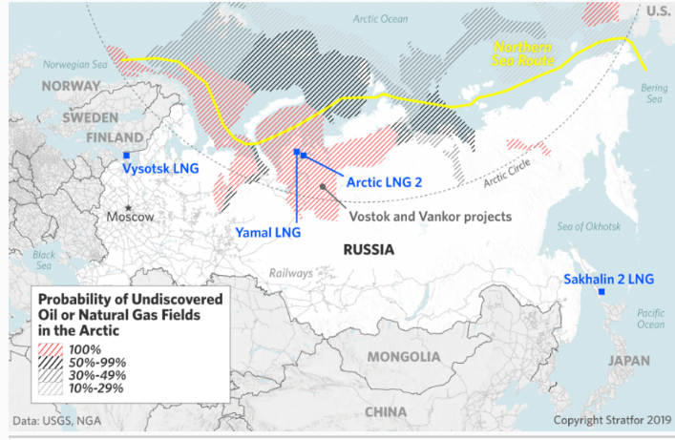
Geopolitical Currents
The Arctic is greener and warmer today due to an unprecedented ice loss and will be ice free before 2050, according to the experts who prepared the National Climate Assessment of 2014. With most of its territorial borders already settled, Arctic is more likely to become a center of attraction due to its vast wealth of resources and new shipping lanes. Russia and Norway have been actively spending on infrastructure, ships, and deep-water ports while China has supported Russian projects, built icebreakers, offered development loans to the Arctic states, and has the largest foreign embassy in Reykjavik.
China’s Arctic Policy is being seen as a shift in the country’s position to become an ‘Arctic stakeholder’ from a ‘near Arctic’ state, with an enhanced influence based on investment and research. The strategic swing has not gone unchecked and is destined to have an impact on other states’ interests and plans. The U.S. is thus being urged by experts to augment its role in the region if it aims ‘to not lose out on this new passage.’ A National Geographic Society report – A thawing Arctic is heating up a new Cold War – contemplates on the possibility of a ‘new Cold War,’ given a lesser attention of Western nations, particularly Canada and the U.S., towards building their own infrastructure and deep-water ports, and a resulting ‘disequilibrium’ of power in the Arctic.
The U.S. Secretary of State, Michael Pompeo, ensured in his May 2019 speech at the Arctic Council Ministerial Meeting that ‘America’s new Arctic focus prioritizes close cooperation with our partners on emerging challenges, including the increased presence and ambitions of non-Arctic nations in the region.’ He stated his government’s vision of ‘fortifying America's security and diplomatic presence and standing up as an Arctic nation in a region that has become ‘an arena of global power and competition’ and at the same time is a land of ‘opportunity and abundance’ being full of oil, gas, gold, uranium, fish, and rare earth minerals. The American decision of stepping out of the Paris Declaration has already been critically received by climate experts, whose only concern about the Arctic hinges on its environmental protection and preservation.
The Arctic states and other interested parties must be aware of impacts of development on marine habitats and preservation of environment and ecosystems. Moreover, the cost of trade and exploration in the midst of harsh Arctic environments may stand as a short-term hurdle but can eventually be transformed into mutual gains and collective opportunities by states that have an obligation either being a circumpolar actor or having interest in the Arctic. Strategic take-offs with extensive magnitude, having deep-rooted global implications, such as those evolving in the Arctic must also make the developing countries recognizant of the level of research and industrial and technical prowess that have to be added to their own national grid of progress, other than the conventional modes of improving economic and security strength.

